**DEPARTMENT OF**

**ELECTRONICS AND COMMUNICATION ENGINEERING**

**College of Engineering and Technology**

**SRM Institute of Science and Technology**

MINI PROJECT REPORT

ODD Semester, 2022-2023

Lab code & Name : 18ECE201J- Python And Scientific Python

Year & Semester : III Year, V semester

Project Title :

Course Teacher **:** Dr. R. Jansi/ Dr. E. Chitra

Electronics and Communication Engineering Department

Team Members : Name (Reg no)

|  |  |  |  |
| --- | --- | --- | --- |
| Reg. No | RA2011004010 | RA2011004010 | RA2011004010 |
| Mark split up |
| Novelty in the project work  (4 marks) |  |  |  |
| Level of understanding of the design formula (8 marks) |  |  |  |
| Contribution to the project  (4 Marks) |  |  |  |
| Report writing (4 Marks) |  |  |  |
| **Total (20 Marks)** |  |  |  |

Date: **Signature of Course Teacher**

**Password Generator using Tkinter Module**

**OBJECTIVE:**

To design a program to generate random password using Tkinter module.

**ABSTRACT:** (min 250 words)

This is program to get an application that can generate a password, with the combination of letters, numerics, and special characters. One can mention length of the password based on requirement and can also select the strength of the password. The application also allows the user to copy the generated password.

**INTRODUCTION:**

With growing technology, everything has relied on data and securing these data is the main concern. Passwords are meant to keep the data safe that we upload on the Internet. An easy password can be hacked easily and all the personal information can be misused. In order to prevent such things and keep the data safe, it is quite necessary to keep our passwords very strong. Here is simple application which can randomly generate passwords based on the user’s preference using Python Tkinter module.

**SOFTWARE REQUIREMENTS:**

Software: Anaconda Navigator & Jupyter, Spyder – Python 3

**CONCEPTS/WORKING PRINCIPLE:**

Through this code, we are trying to develop a GUI application using “Tkinter” that will generate a random password based on the user’s preference. For this we are using the “random” module. And to copy the random password to the clipboard “pyperclip” module is used.

**FLOWCHART:**

**(Paste the flowchart of your project here)**

**PROGRAM/ APPROACH/METHODOLOGY:**

from tkinter import *

from random import randint

root = Tk()

root.title('Codemy.com - Strong Password Generator')

root.iconbitmap('c:/gui/codemy.ico')

root.geometry("500x300")

# Generate Random Strong Password

def new_rand():

# Clear Our Entry Box

pw_entry.delete(0, END)

# Get PW Length and convert to integer

pw_length = int(my_entry.get())

# create a variable to hold our password

my_password = ''

# Loop through password length

for x in range(pw_length):

my_password += chr(randint(33,126))

# Output password to the screen

pw_entry.insert(0, my_password)

# Copy to clipboard

def clipper():

# Clear the clipboard

root.clipboard_clear()

# Copy to clipboard

root.clipboard_append(pw_entry.get())

# Label Frame

lf = LabelFrame(root, text="How Many Characters?")

lf.pack(pady=20)

# Create Entry Box To Designate Number of Characters

my_entry = Entry(lf, font=("Helvetica", 24))

my_entry.pack(pady=20, padx=20)

# Create Entry Box For Our Returned Password

pw_entry = Entry(root, text='', font=("Helvetica", 24), bd=0, bg="systembuttonface")

pw_entry.pack(pady=20)

# Create a frame for our Buttons

my_frame = Frame(root)

my_frame.pack(pady=20)

# Create our Buttons

my_button = Button(my_frame, text="Generate Strong Password", command=new_rand)

my_button.grid(row=0, column=0, padx=10)

clip_button = Button(my_frame, text="Copy To Clipboad", command=clipper)

clip_button.grid(row=0, column=1, padx=10)

root.mainloop()

**OUTPUT:**

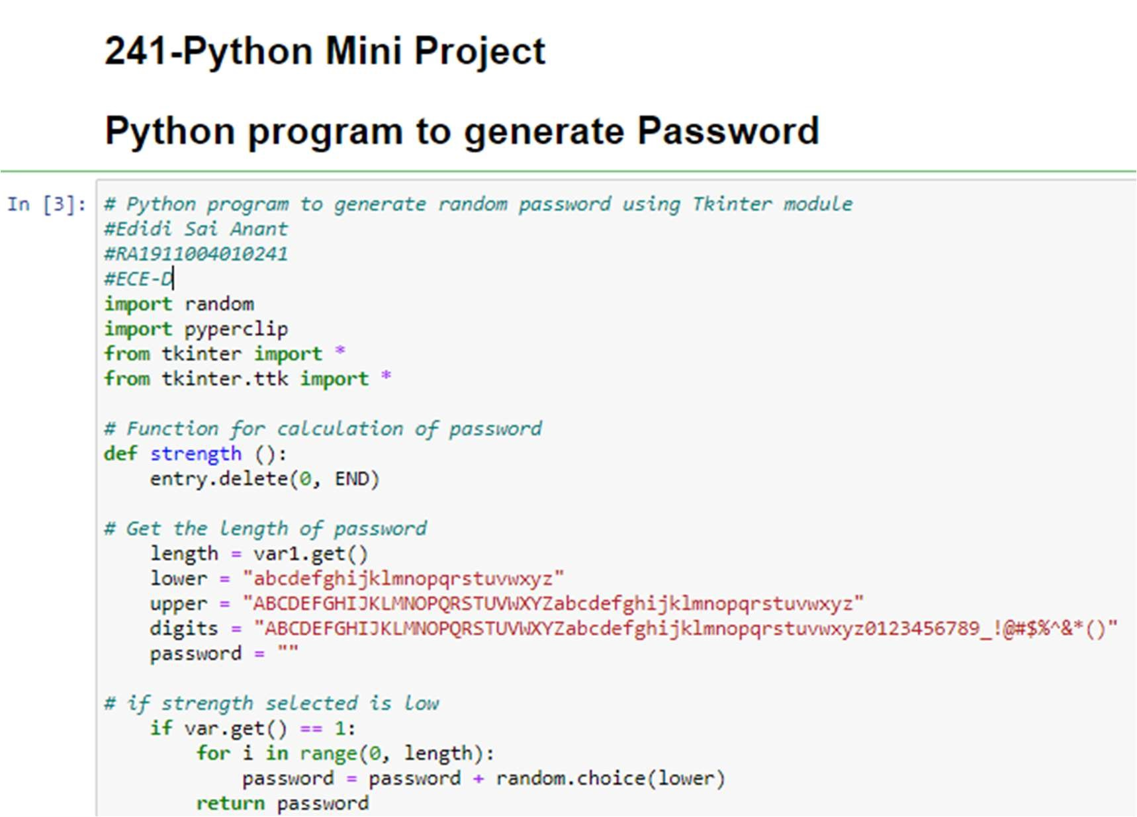

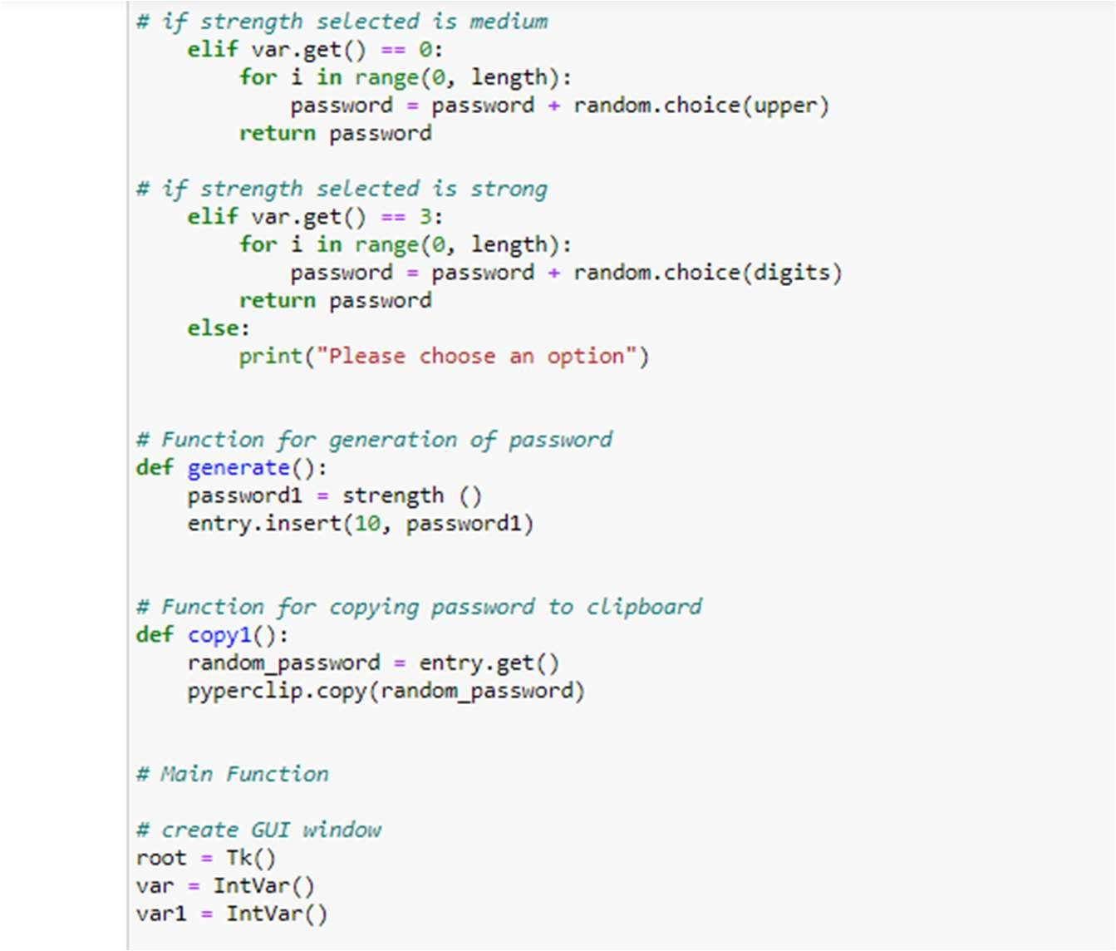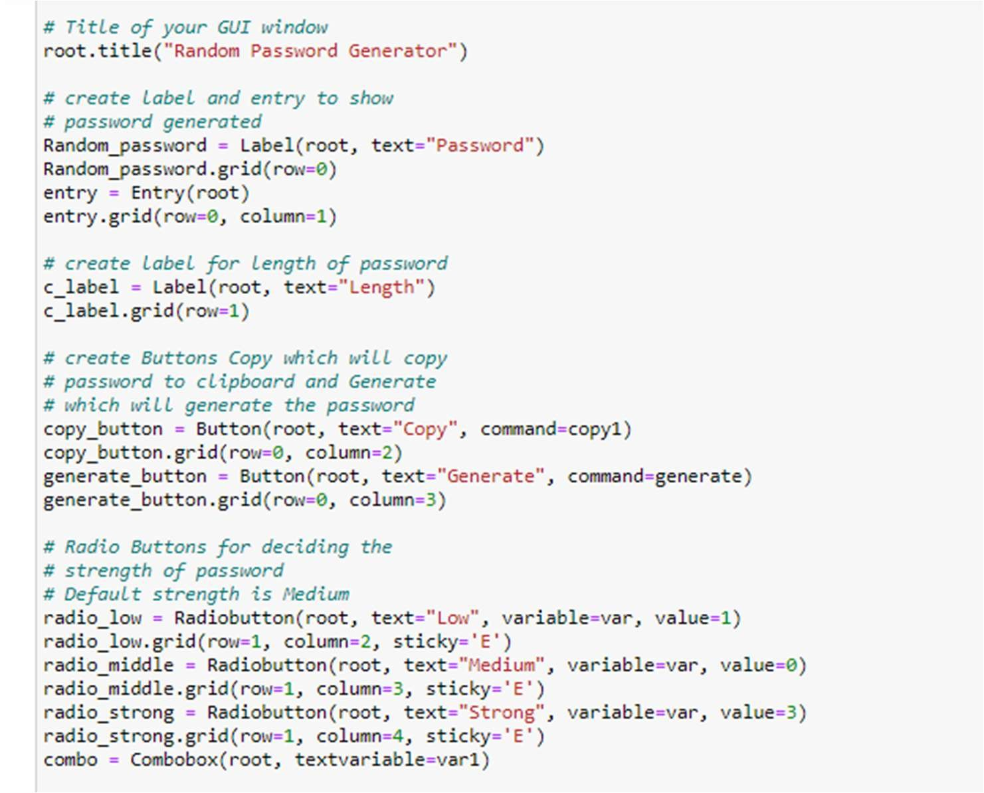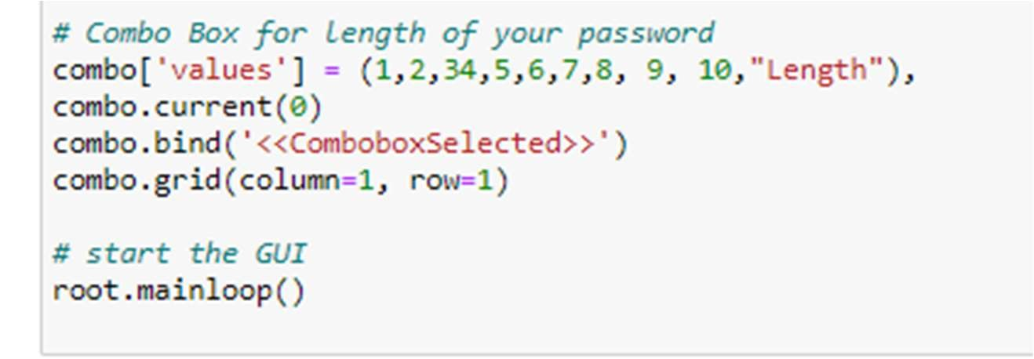

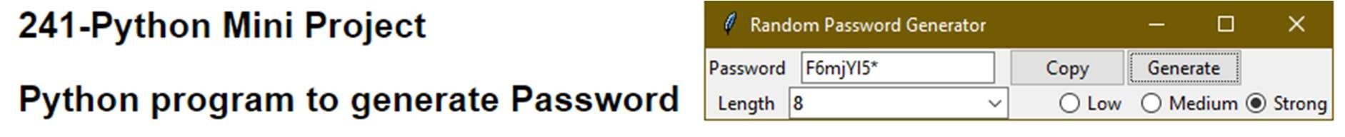

**CONCLUSION:**

Hence, a program to generate password was designed using Tkinter module in Python.

**REFERENCES:**

https://www.geeksforgeeks.org

https://www.geeksforgeeks.org/python-gui-tkinter/